

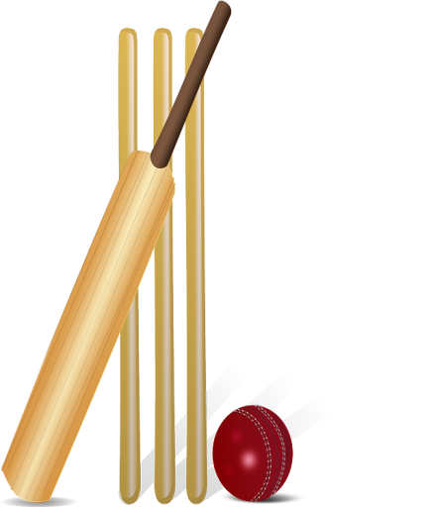 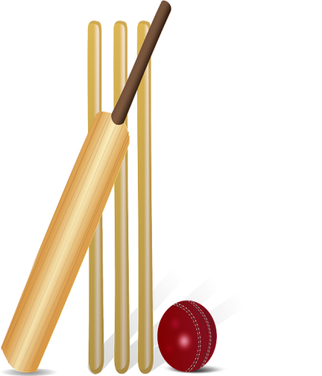

**Purley on Thames CC – Junior Presentation Evening**

Please join us on **Friday 20th July from 6.30pm** outside at the Cricket Club

for the Junior Club Presentation & “informal” games evening (weather permitting, otherwise inside!)

***Presentations to All Stars, Under 9s, Under 11s, Under 13s, Under 15s, Under 17s & Girls***

*There will be burgers, hotdogs, veggie option, chips, plus BAR, available from Sports & Social Club*

*Also, an ice cream van situated in the car park…*

*We will put out various cricket equipment for your use after Presentations…*

***Please come & enjoy yourselves!! ALL WELCOME!!***